F-CAP CHINESE CURRICULUM COMMITTEE
Level 4 Stamps
UNIT 2: Technology and Contemporary Life

Name: | Class Period:

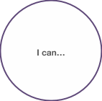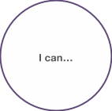

Can do without help ____ (2) | Can do it with help _____ (1) | Need to learn _____

